Stage

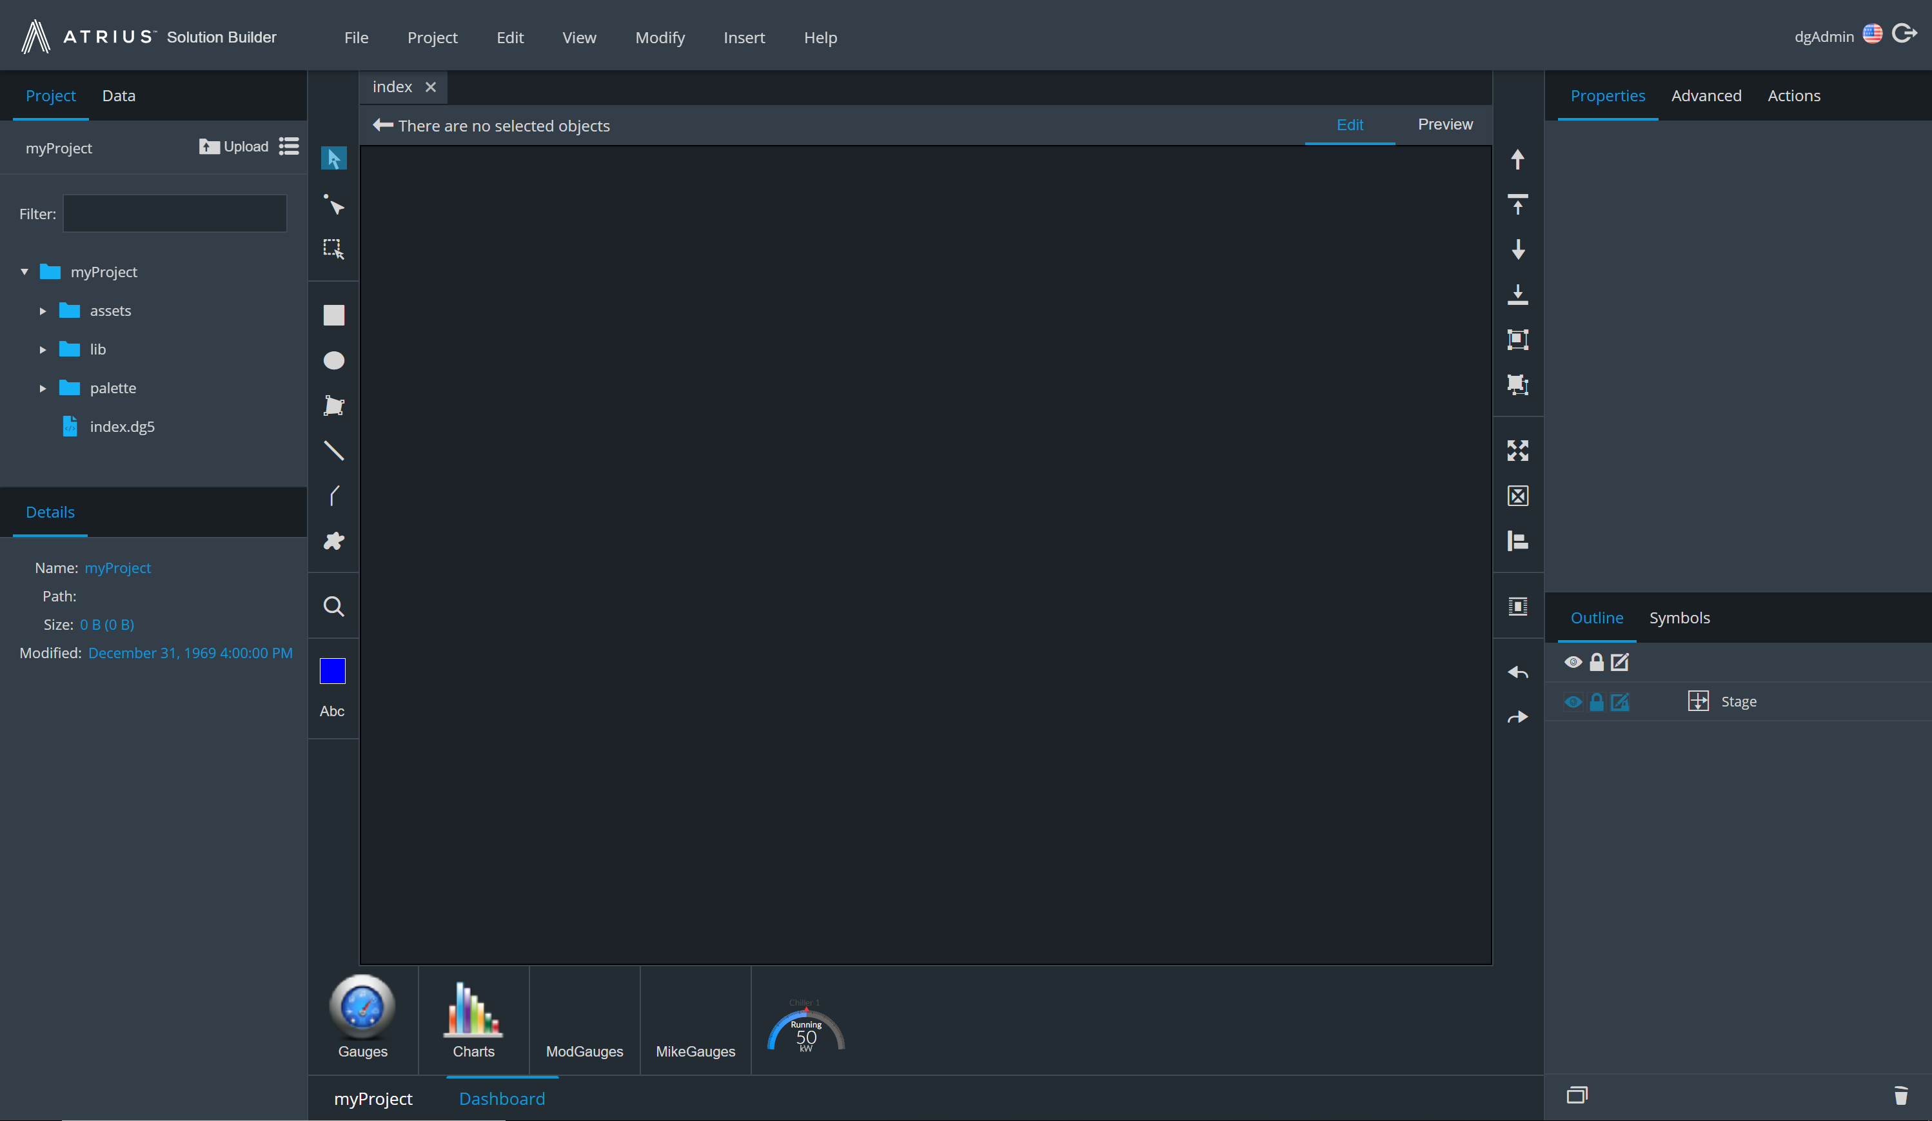

Outline pane

Properties pane

Project/Data pane

Widgets